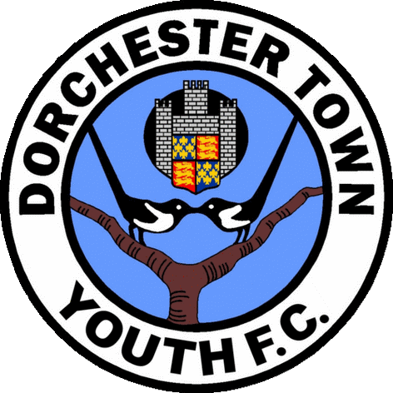
Dorchester Town Youth F.C Registration Form Season 2023/24

- Registration details

Team name …………………………………………………. Under ……………

Player’s name ……………………………………………………………………...
School ………………………………………….……….. School year……………
Players Date of birth …………………………..…………………………………………………………….
Players Address ……………………………………………………………………………………………...
……………………………………………………………………..Postcode ………………………………
Landline …………………………………… Mobile (parent/guardian) ……………………………………
Name of parent/guardian or another person responsible ……………………………………………………
Parent/guardian e-mail address …………………………………………………………...…………………
Parent/guardian date of birth ………………………………………………………………………………..
Alternative emergency contact name / number …………………………………………………………….
Doctors name, address and telephone number ………………………………………………………………
……………………………………………………………………………………………………………….. Any relevant facts about your child, for example disabilities, medicines etc, which you would like the Team Manager and Club Secretary to be aware of and be noted with complete confidence
………………………………………………………………………………………………………………..
………………………………………………………………………………………………………………..

Conditions of Registration
  - Dorchester Town Youth FC has arranged personal accident insurance cover for all players and officials covering training sessions, travel and competitive matches. The types of accidents covered are: accidental death, permanent total disablement, loss of eyes and/or limbs, dental damage, fractures and any accident requiring physiotherapy. If at any time you believe that you have reason to submit an insurance claim please contact the Club Secretary via your team manager within 24 hours of said accident occurring.
  - Dorchester Town Youth FC cannot be held responsible for any clothing, equipment or money lost during training sessions, matches or other club activities.
  - The above personal information is the only data retained on the Dorchester Town Youth FC electronic database. It is also entered on to the Football Association Whole Game System for the purpose of registering players. If you are unhappy with your information being retained on our computer or you would like a print out of the data please contact the club secretary via your team manager. Following the introduction of the new General Data Protection Regulation (GDPR) in May 2018 a Data Protection Policy can be found in the documents section of the DTYFC website.
  - Annual Fees for the 2023/24 season are £200 for players registered to play for a team. A first payment of £150 must be paid when signing on and a second payment of £50 in January 2024. A player’s photo identification card will not be released to the team manager until the first fee instalment has been paid. The full fee of £200 can be paid at registration if this is more convenient. A payment plan can be set up by prior arrangement again the first instalment must be paid upon registration which is £50 followed by 5 monthly standing order payments of £30. Trainer only and reception fees are £120. A first payment of £80 must be paid when registering and a second payment of £40 in January 2024. If a trainer or reception member wishes to set up a payment plan then the first instalment will be £40 upon registration followed by 4 monthly standing order payments of £20. Please note no payment can be made unless accompanied by the members individual reference number which can be obtained by the Chairman or Treasurer of DTYFC.
  - Bank details are Account Name: Dorchester Town Youth Football Club; Sort Code 30-92-69; Account No 01185141.
  - Fees for players that join part way through the season will be as follows: up to the 31st October (£200.) November & December (£170) and any time after 1st January (£130) registered player.

  - A player may be temporarily stopped from playing for a Dorchester Town Youth FC team if their fees have not been paid by the relevant payment date.
  - The club issues codes of conducts governing the expected behaviour of both players and spectators. Any failure to comply with those standards will be discussed with you and in extreme circumstances could lead to a player and/or supporters being excluded from club activities. Visit youth.dorchestertownfc.com for details.
  - Dorchester Town Youth FC will not be responsible for paying any fines that have been incurred for yellow/red cards, or misconduct charges, this responsibility will sit with the individual player/team. Failure to pay any fines in full may lead to a player’s registration being suspended and may also have an effect on that teams end of season trophy money.
  - At the end of the season each team may be allocated an agreed amount of money that can be used to purchase trophies. However, this will depend on all of the teams/players fees being fully paid and there being sufficient funds in the Dorchester Town Youth accounts.
  - A player will not be allowed to train or play with a Dorchester Town Youth FC team until a signed copy of this form has been submitted for the current season.
  - If a player is chosen for the playing squad on a match day then they are to expect a minimum of approximately half a game (within reason or unless circumstances prevail eg, injury or sickness). Please contact the team manager and / or the committee with any concerns regarding playing time.
  - The club issues photographs of teams and match action for publicity leaflets, press coverage and its own website. If you are NOT happy for your child’s name and/or photograph to be used for these purposes, please delete 3.3 below when signing this form.
- Consent
  - I accept the conditions of registration 2.1 to 2.13 above
  - I consent to emergency treatment being administered to my child, should it be required and authorise the club representative to sign on my behalf any written consent required by the emergency services should delay required to obtain my signature be considered by the authority concerned likely to endanger my child's health and safety. This is on understanding that every effort will be made to contact me.
  - I agree to pictures of my child being used for publicity purposes as specified in 2.13 above.
  - For all club documents please visit youth.dorchestertownfc.com

Signed …………………………………… Name (capitals) …………..…………………………………

Date ………………………………………

Please return this form to your child’s Team Manager as soon as possible. Failure to do so may prevent your child being able to participate in any club activities.

