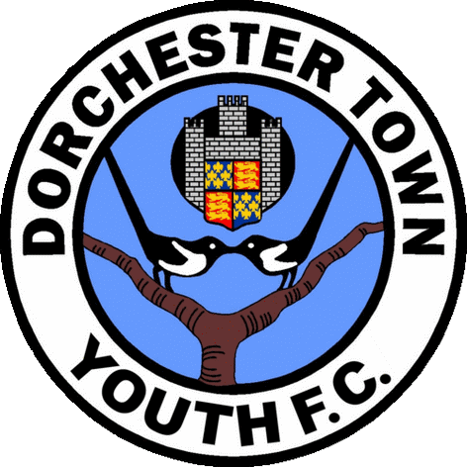
Player Registration Details
Team Name: |  |  |  |  |  |  | Under:
Player Details
Name:
Date of Birth: |  |  |  | School Year at start of season:
School:
Parent / Guardian Details
Name:
Address:
Postcode: |  |  | Phone No:
Email: |  |  |  |  |  |  | Date of Birth:
Emergency Contact Details
Name:
Relationship to Player |  |  |  |  |  | Phone No:
Doctors name, address, phone no:
Any relevant facts about your child, for example disabilities, medicines etc, which you would like the Team Manager and Club Secretary to be aware of and be noted with complete confidence

Fees
Annual Fees for the 2024/25 season are £200 for players registered to play for a team.
A first payment of £150 must be paid when signing on and a second payment of £50 in January 2025. The full fee of £200 can be paid at registration if this is more convenient.
A payment plan can be set up by prior arrangement again the first instalment must be paid upon registration which is £50 followed by 5 monthly standing order payments of £30.
Trainer only and reception fees are £120. A first payment of £80 must be paid when registering and a second payment of £40 in January 2025. If a trainer or reception member wishes to set up a payment plan then the first instalment will be £40 upon registration followed by 4 monthly standing order payments of £20.
Please note all payments must be accompanied by the members individual reference number which can be obtained from the Chairman or Treasurer of DTYFC.
Bank details are Account Name: Dorchester Town Youth Football Club; Sort Code 30-92-69; Account No 01185141.
Fees for registered players that join part way through the season will be as follows: up to the 31st October (£200.) November & December (£170) and any time after 1st January (£130).
A player’s photo identification card will not be released to the team manager until the first fee instalment has been paid.
A player may be temporarily suspended from playing for a Dorchester Town Youth FC team if their fees have not been paid by the relevant payment date.

Conditions of Registration
Dorchester Town Youth FC has arranged personal accident insurance cover for all players and officials covering training sessions and official matches (arranged by the club, league or FA). The types of accidents covered are: accidental death, permanent total disablement, loss of eyes and/or limbs, dental damage, fractures and any accident requiring physiotherapy. If at any time you believe that you have reason to submit an insurance claim please contact the Club Secretary via your team manager within 24 hours of said accident occurring.
Dorchester Town Youth FC cannot be held responsible for any clothing, equipment or money lost during training sessions, matches or other club activities.
The above personal information is the only data retained on the Dorchester Town Youth FC electronic database. It is also entered on to the Football Association Whole Game System for the purpose of registering players. If you are unhappy with your information being retained on our computer or you would like a print out of the data please contact the club secretary via your team manager. A data Protection Policy can be found in the documents section of the DTYFC website.
Dorchester Town Youth FC will not be responsible for paying any fines that have been incurred for yellow/red cards, or misconduct charges, this responsibility will sit with the individual player/team. Failure to pay any fines in full may lead to a player’s registration being suspended and may also have an effect on that teams end of season trophy money.
A player will not be allowed to train or play with a Dorchester Town Youth FC team until a signed copy of this form has been submitted for the current season.
From time to time the club may issue photographs of teams and match action for publicity leaflets, press coverage and its own website. If you are NOT happy for your child’s name and/or photograph to be used for these purposes, please delete the relevant line of the consent below when signing this form.
Club Responsibilities
In accepting the player for registration with the club Dorchester Town Youth FC will provide a safe and enjoyable environment for them to train and play football.
The club will retain FA accreditation and adhere to all league and FA requirements. This includes; ensuring that all managers and coaches are appropriately qualified and have the correct safeguarding and DBS checks; providing personal accident insurance as described in 3.1; publishing all relevant policies and documentation on our website.
If a player is chosen for the playing squad on a match day then they are to expect a minimum of approximately half a game (within reason or unless circumstances prevail e.g, injury or sickness). Please contact the team manager and / or the committee with any concerns regarding playing time.
At the end of the season each team may be allocated an agreed amount of money that can be used to purchase trophies. However, this will depend on all of the teams/players fees being fully paid and there being sufficient funds in the Dorchester Town Youth accounts
Player Responsibilities
All youth members of the club are expected to follow the club and FA policies on conduct and behavior at all times. They should enhance the ethos of the club for providing safe and enjoyable football for all, setting a good example and high standard when representing DTYFC, with a particular emphasis on Respect towards all involved.
Players are responsible for having the appropriate equipment and kit when attending training and matches, including shin pads and the right boots for the playing surface.
Parent / Guardian Responsibilities
Parents, guardians and other adults supporting the youth players are expected to follow the club and FA policies on conduct and behavior at all times. In particular please be aware of the policies regarding photography and Respect (see our website).
All payments must be made on time, for the agreed amount and with the correct reference.
You are responsible for making appropriate arrangements for the safe drop-off and pick-up of players at training and matches. It is expected that this will be at the times indicated by you team manager and all reasonable efforts will be made to adhere to these. In the event of unexpected delays you will urgently contact the manager to make alternative arrangements. You should notify the manager of any changes to the usual routine, such as if others are picking up other players or providing transport for them. Irrespective of their age a player should only leave a session or match with an appropriate adult. You must notify and agree with the team manager if you are proposing they travel independently.

Consent
I accept the conditions of registration 2.1 to 3.15 above
I consent to emergency treatment being administered to my child, should it be required and authorise the club representative to sign on my behalf any written consent required by the emergency services should delay required to obtain my signature be considered by the authority concerned likely to endanger my child's health and safety. This is on understanding that every effort will be made to contact me.
I agree to pictures of my child being used for publicity purposes as specified in 3.6 above. Please delete this line if you do not agree.
For all club documents please visit youth.dorchestertownfc.com

Signed ……………………………….………… Name (capitals) …………………..……………………………… Date …………………

Please return this form to your child’s Team Manager as soon as possible. Failure to do so may prevent your child being able to participate in any club activities.

